ACCOUNTING MANAGEMENT SYSTEM

**MADE BY:**

**M.Umer Nasir 21k-3425**

# **Purpose:**

The purpose of the project is to perform the following tasks:

1. Allow user to create a General Journal in Excel
2. Allow user to adjust any entry in the Journal
3. The program will create the Trial Balance in Excel
4. The program will create the T account in Excel

# Create a new account or login screen:

Allows user to create a new account with password or login with the previous one.

# General Journal:

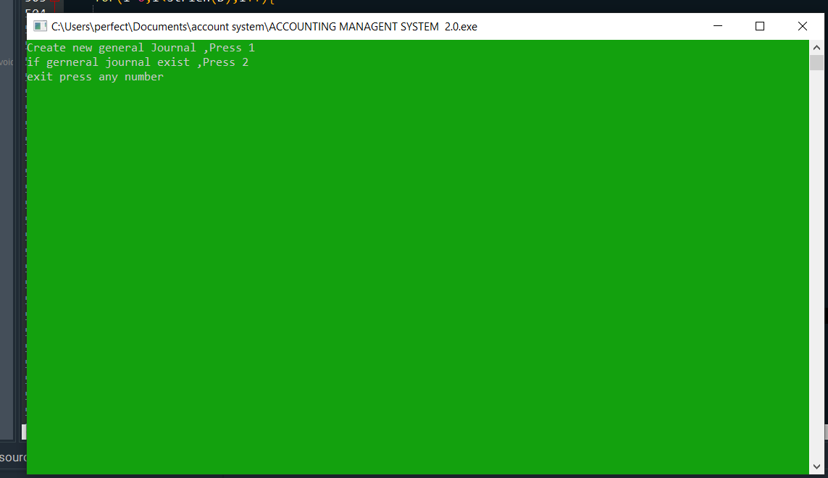User can either create a new Journal for entries or access existing ones.

## Adjust entry, Trial Balance and T account:

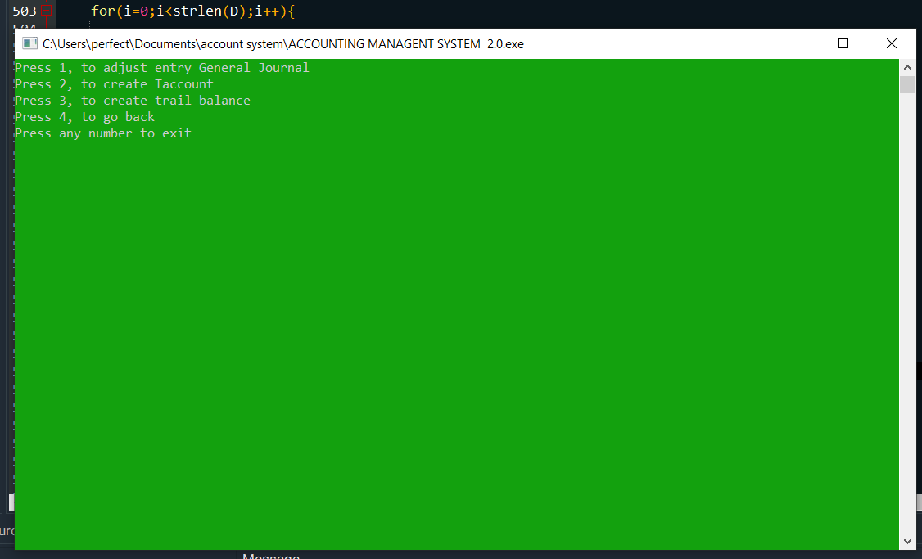

In this menu screen user are given the option to update any entry, create t accounts and create trail balance (which is made by the program).

**Q# 3**

Journalizing transactions, posting journal entries to four-column accounts, and preparing a trial balance

Theodore McMahon opened a law office on January 1, 2018. During the first month of operations, the business completed the following transactions:

Jan. 1 McMahon contributed $79,000 cash to the business, Theodore McMahon, Attorney. The business issued common stock to McMahon.

3 Purchased office supplies, $1,000, and furniture, $1,300, on account.

4 Performed legal services for a client and received $1,500 cash.

7 Purchased a building with a market value of $80,000, and land with a market value of $29,000. The business paid $70,000 cash and signed a note payable to the bank for the remaining amount.

11 Prepared legal documents for a client on account, $600.

15 Paid assistant’s semimonthly salary, $1,130.

16 Paid for the office supplies purchased on January 3 on account.

18 Received $2,100 cash for helping a client sell real estate.

19 Defended a client in court and billed the client for $900.

25 Received a bill for utilities, $450. The bill will be paid next month.

29 Received cash on account, $900.

30 Paid $960 cash for a 12-month insurance policy starting on February 1.

30 Paid assistant’s semimonthly salary, $1,130.

31 Paid monthly rent expense, $1,000.

31 Paid cash dividends of $2,100

# Outputs:

## General Journal:

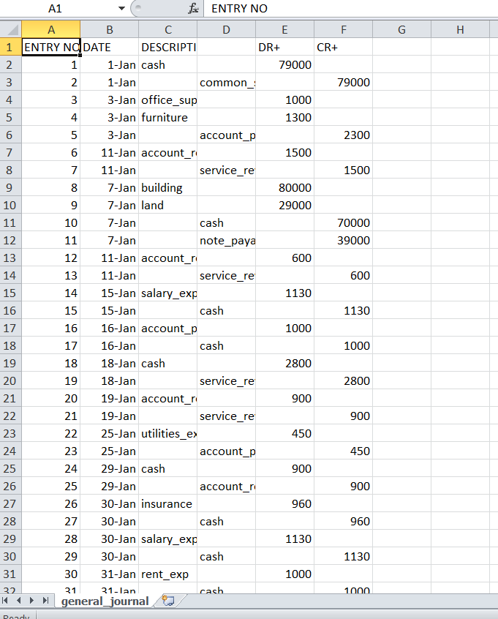

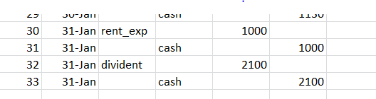

## T accounts:

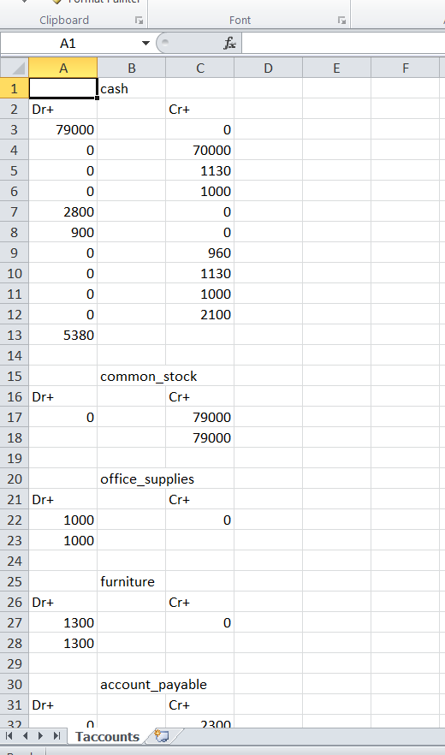

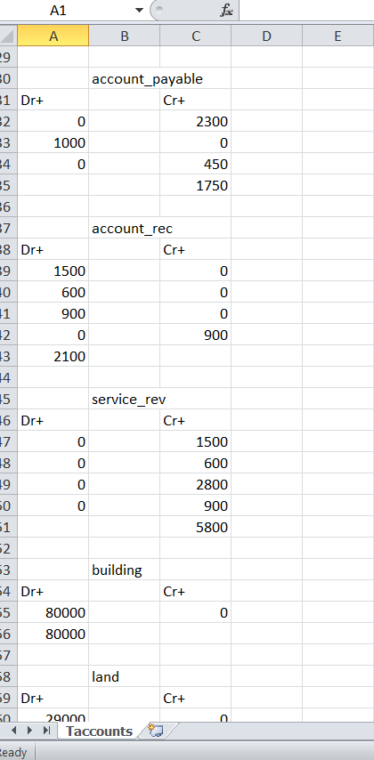

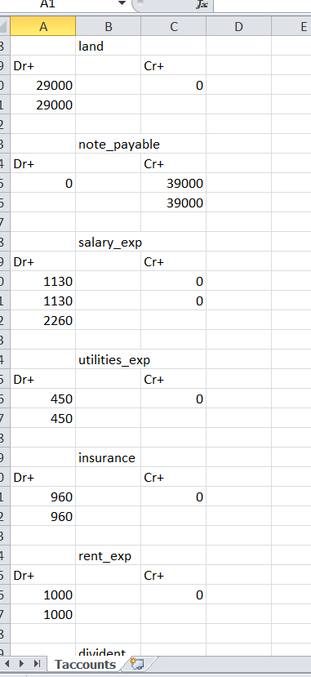

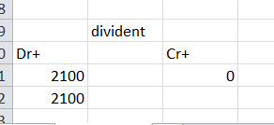

## Trial Balance:

